Geometry Projection

Definition
# Source: AI Source: Provided by: [Data Path: Persons Table -> ID Column: 1, Name_En Column: Motasem Essam] -> From: [ChatGPT] on [7/25/2026]
In geometry, a projection is a mapping that represents a geometric object on another geometric object, such as a line, plane, or coordinate axis.
The most common type in elementary plane geometry is orthogonal projection, where a point or figure is projected onto a line along a direction perpendicular to that line.
For a point $P$ projected onto a line $l$, if $P^{'}$ is its projection:
$$\boxed{PP^{'}⟂l}$$
and $P^{'}$ is called the projection of $P$ onto $l$.

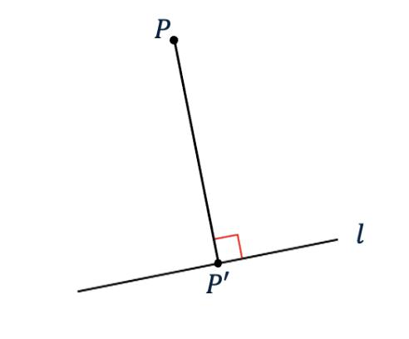
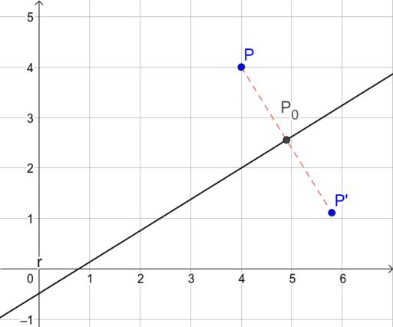
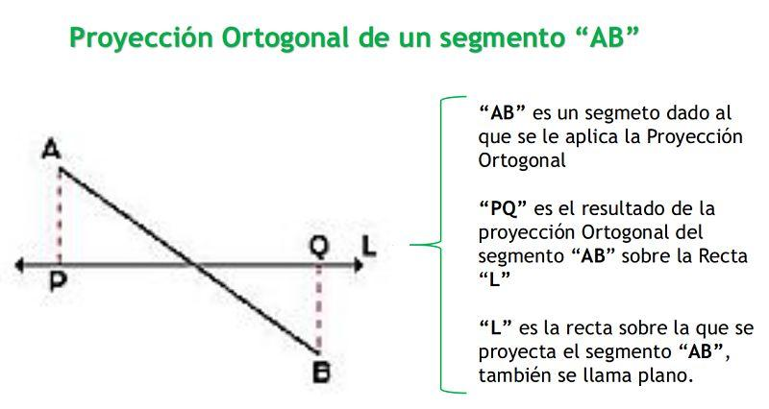

Purpose
# Source: AI Source: Provided by: [Data Path: Persons Table -> ID Column: 1, Name_En Column: Motasem Essam] -> From: [ChatGPT] on [7/25/2026]
Projection is used to:
- Represent a geometric object on a lower-dimensional object.
- Find perpendicular distances.
- Determine the component of a vector in a particular direction.
- Calculate heights and bases of triangles.
- Simplify geometric problems.
- Represent 3D objects on a 2D surface.
- Analyze shadows, maps, engineering drawings, and computer graphics.

Basic Configuration
# Source: AI Source: Provided by: [Data Path: Persons Table -> ID Column: 1, Name_En Column: Motasem Essam] -> From: [ChatGPT] on [7/25/2026]
Consider a point $P$ and a line $l$.
Drop a perpendicular from $P$ to $l$.
Let $P^{'}$ be the point where the perpendicular meets $l$.
Then:
$$\boxed{PP^{'}⟂l}$$
Therefore, $P^{'}$ is the orthogonal projection of $P$ onto $l$.
The distance:
$$\boxed{PP^{'}}$$
is the perpendicular distance from $P$ to the line $l$.

Types of Geometric Projection
# Source: AI Source: Provided by: [Data Path: Persons Table -> ID Column: 1, Name_En Column: Motasem Essam] -> From: [ChatGPT] on [7/25/2026]
Projection can be classified according to the direction and mathematical model used.
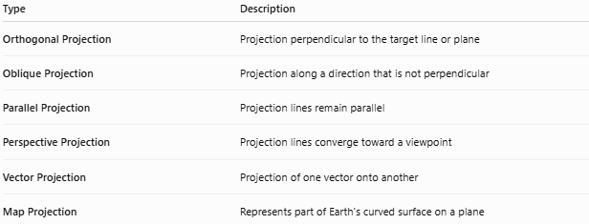
Type | Description
Orthogonal Projection | Projection perpendicular to the target line or plane
Oblique Projection | Projection along a direction that is not perpendicular
Parallel Projection | Projection lines remain parallel
Perspective Projection | Projection lines converge toward a viewpoint
Vector Projection | Projection of one vector onto another
Map Projection | Represents part of Earth's curved surface on a plane
For elementary plane geometry, orthogonal projection is usually the most important.

1. Orthogonal Projection
# Source: AI Source: Provided by: [Data Path: Persons Table -> ID Column: 1, Name_En Column: Motasem Essam] -> From: [ChatGPT] on [7/25/2026]
An orthogonal projection projects an object onto a line or plane along perpendicular directions.

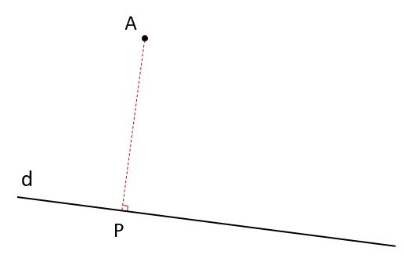
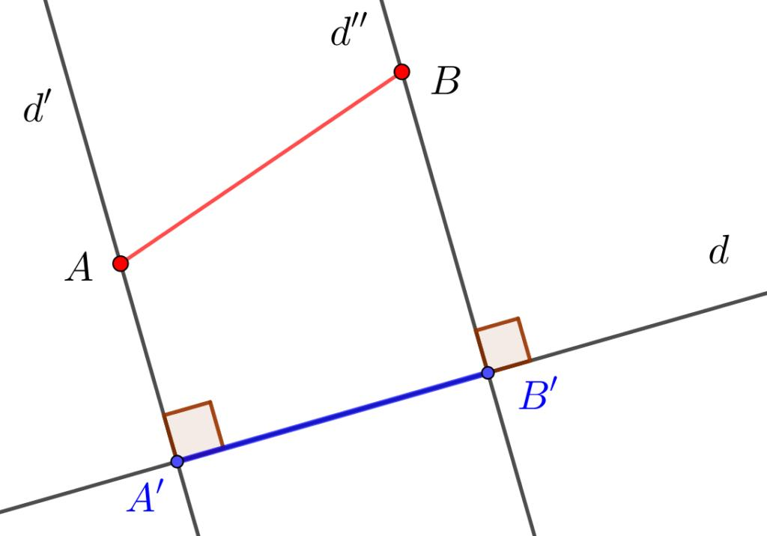
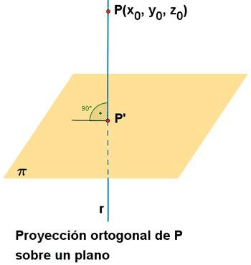
6
For a point $P$ projected onto line $l$:
$$\boxed{PP^{'}⟂l}$$
Important Property
The orthogonal projection gives the shortest distance from the point to the line.

2. Projection of a Line Segment
# Source: AI Source: Provided by: [Data Path: Persons Table -> ID Column: 1, Name_En Column: Motasem Essam] -> From: [ChatGPT] on [7/25/2026]
Suppose segment $\overline{AB}$ is projected onto a line $l$.
The endpoints $A$ and $B$ are projected to $A^{'}$ and $B^{'}$.
The resulting segment:
$$\boxed{\overline{A^{'}B^{'}}}$$
is the projection of $\overline{AB}$ onto $l$.

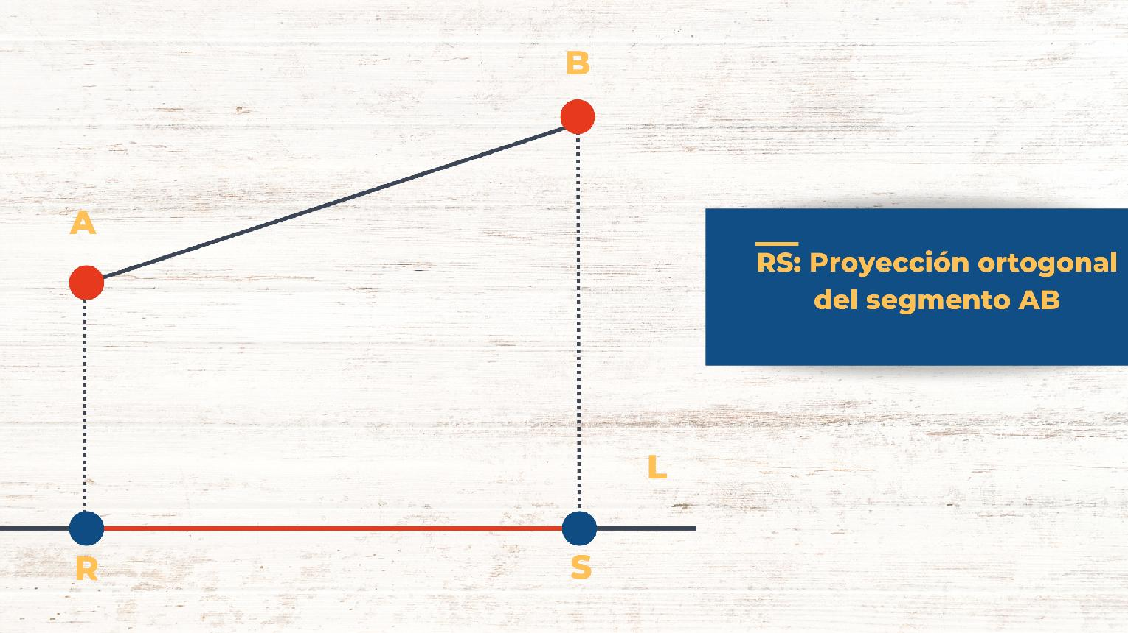
If $θ$ is the angle between $AB$ and the projection line:
$$\boxed{A^{'}B^{'}=AB|cosθ|}$$
This is an important relationship between a segment and its projection.

Example 1: Segment Projection
Suppose:
$$AB=10\text{ cm}$$
and the angle between $AB$ and the projection line is:
$$θ={60}^{∘}$$
Then:
$A^{'}B^{'}=ABcos{60}^{∘}$ $A^{'}B^{'}=10\left(\frac{1}{2}\right)$
Therefore:
$$\boxed{A^{'}B^{'}=5\text{ cm}}$$

3. Projection in a Triangle
# Source: AI Source: Provided by: [Data Path: Persons Table -> ID Column: 1, Name_En Column: Motasem Essam] -> From: [ChatGPT] on [7/25/2026]
Projection is closely related to altitudes.
Consider triangle $ABC$. Project $A$ onto $BC$, producing point $D$.
Then:
$$\boxed{AD⟂BC}$$
Therefore, $D$ is the orthogonal projection of $A$ onto $BC$.

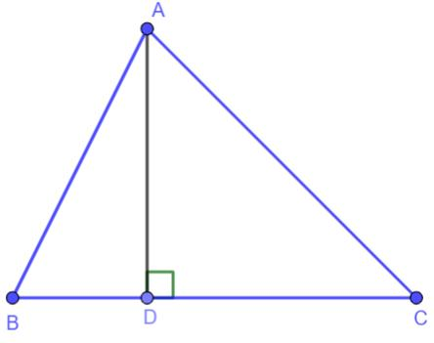
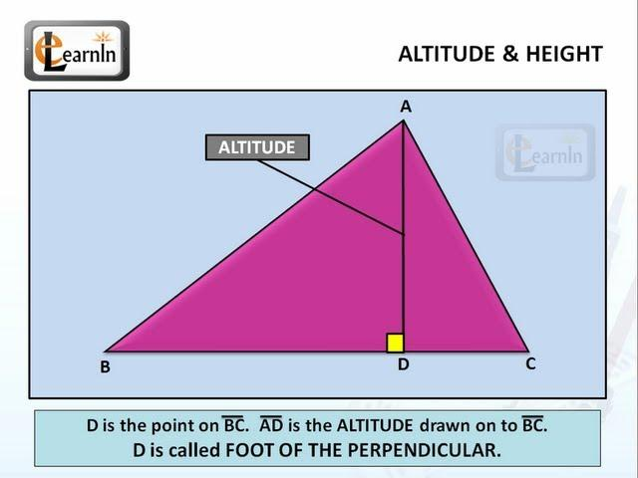
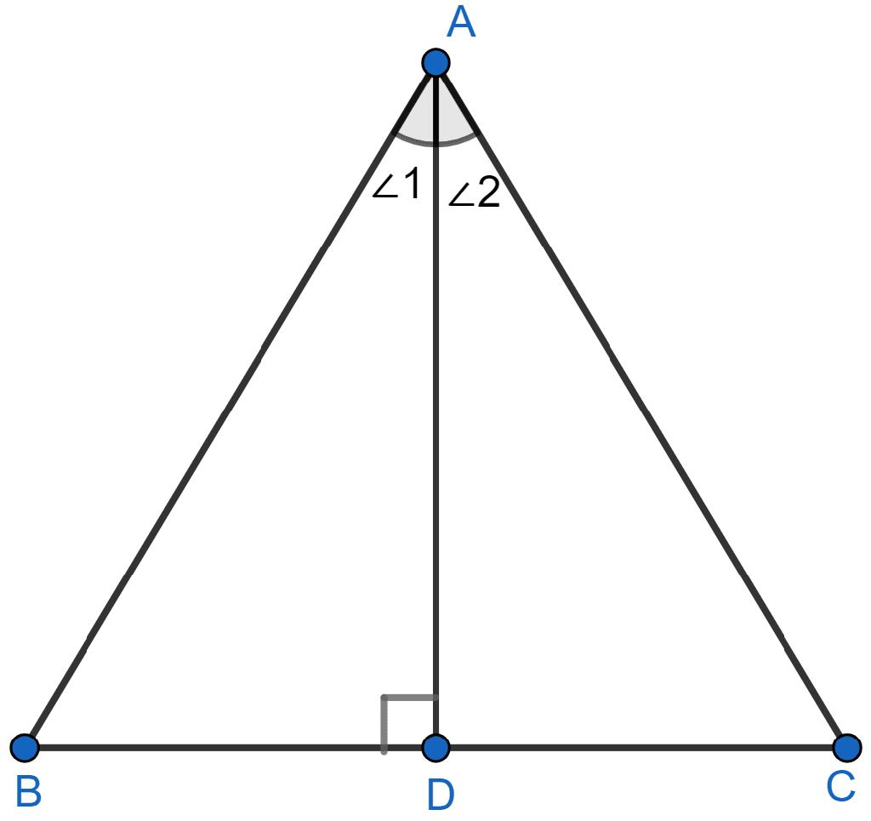
This means:
$$\boxed{\text{Foot of altitude}=\text{orthogonal projection of the vertex}}$$
This is an important connection between projection and triangle altitude.

4. Projection and Trigonometry
# Source: AI Source: Provided by: [Data Path: Persons Table -> ID Column: 1, Name_En Column: Motasem Essam] -> From: [ChatGPT] on [7/25/2026]
Projection is strongly connected to cosine.
For a segment of length $L$ making an angle $θ$ with a line:
$$\boxed{L_{\text{projection}}=L|cosθ|}$$
For example, if:
$$L=20$$
and:
$$θ={30}^{∘}$$
then:
$L_{\text{projection}}=20cos{30}^{∘}$ $=20\left(\frac{\sqrt{3}}{2}\right)$
Therefore:
$$\boxed{L_{\text{projection}}=10\sqrt{3}}$$

5. Vector Projection
# Source: AI Source: Provided by: [Data Path: Persons Table -> ID Column: 1, Name_En Column: Motasem Essam] -> From: [ChatGPT] on [7/25/2026]
Projection is also important in vector geometry.
The projection of vector $\vec{a}$ onto vector $\vec{b}$ is:
$$\boxed{{proj}_{\vec{b}}\vec{a}=\frac{\vec{a}⋅\vec{b}}{∥\vec{b}∥^{2}}\vec{b}}$$
The corresponding scalar projection is:
$$\boxed{{comp}_{\vec{b}}\vec{a}=\frac{\vec{a}⋅\vec{b}}{∥\vec{b}∥}}$$
where:
- $\vec{a}⋅\vec{b}$ is the dot product.
- $∥\vec{b}∥$ is the magnitude of $\vec{b}$.

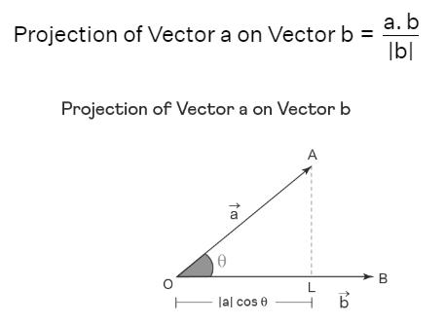
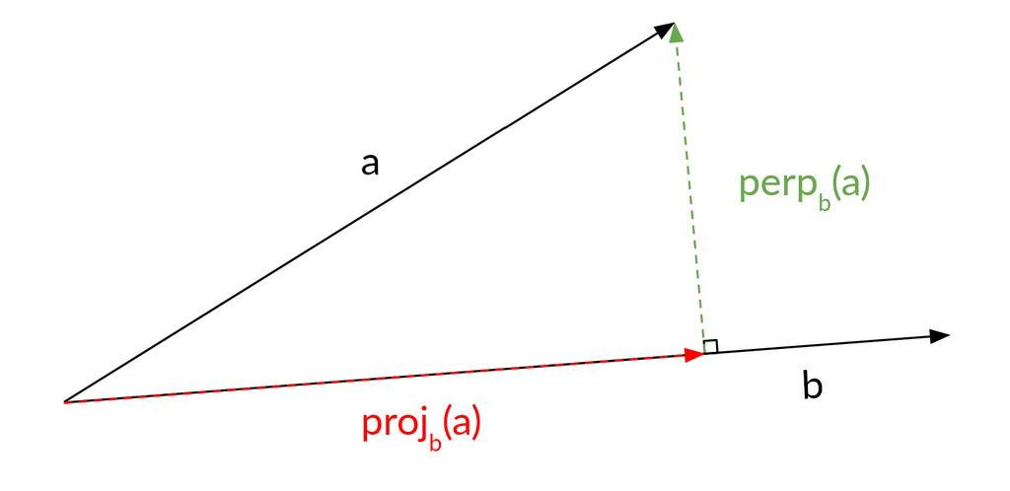
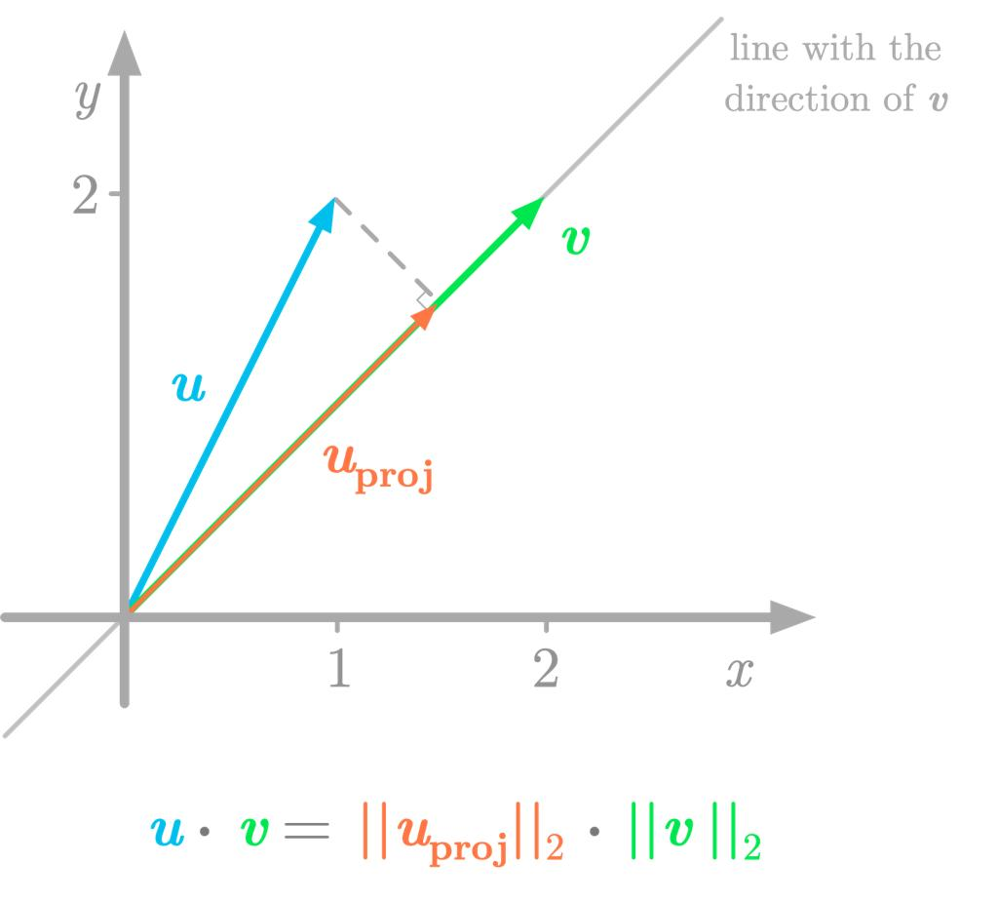
5

Example 2: Vector Projection
Let:
$$\vec{a}=(3,4)$$
and:
$$\vec{b}=(1,0)$$
Then:
$$\vec{a}⋅\vec{b}=(3)(1)+(4)(0)=3$$
and:
$$∥\vec{b}∥^{2}=1$$
Therefore:
${proj}_{\vec{b}}\vec{a}=\frac{3}{1}(1,0)$ $\boxed{{proj}_{\vec{b}}\vec{a}=(3,0)}$
The projection keeps the horizontal component and removes the vertical component.

6. Oblique Projection
# Source: AI Source: Provided by: [Data Path: Persons Table -> ID Column: 1, Name_En Column: Motasem Essam] -> From: [ChatGPT] on [7/25/2026]
In an oblique projection, the projection lines are not perpendicular to the target line or plane.
Thus, unlike orthogonal projection:
$$PP^{'}⟂̸l$$
in general.
Oblique projection is frequently used in technical and engineering drawings.

7. Parallel Projection
# Source: AI Source: Provided by: [Data Path: Persons Table -> ID Column: 1, Name_En Column: Motasem Essam] -> From: [ChatGPT] on [7/25/2026]
In parallel projection, all projection lines are parallel.
There are two major cases:
- Orthographic projection
- Oblique projection
The projection direction stays constant.
This is useful for technical drawings because parallel edges can remain parallel in the projected representation.

8. Perspective Projection
# Source: AI Source: Provided by: [Data Path: Persons Table -> ID Column: 1, Name_En Column: Motasem Essam] -> From: [ChatGPT] on [7/25/2026]
In perspective projection, projection lines pass through a common point called the viewpoint or center of projection.

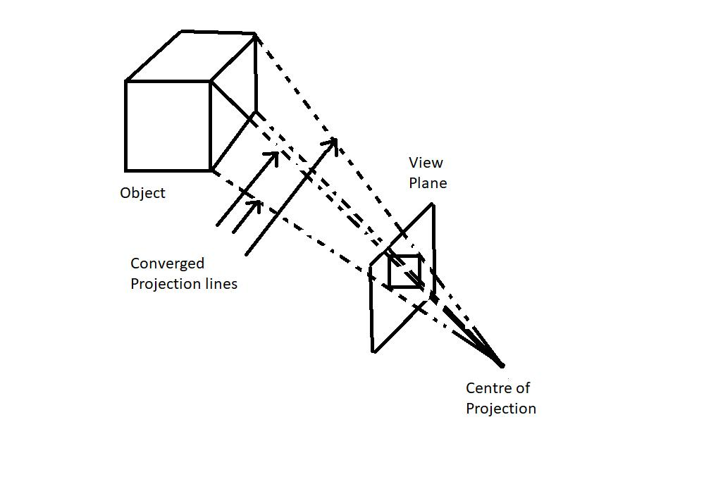
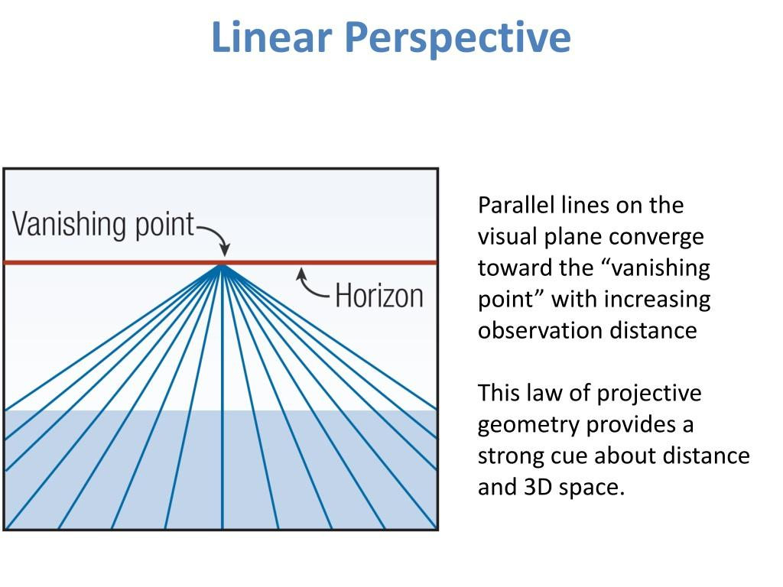
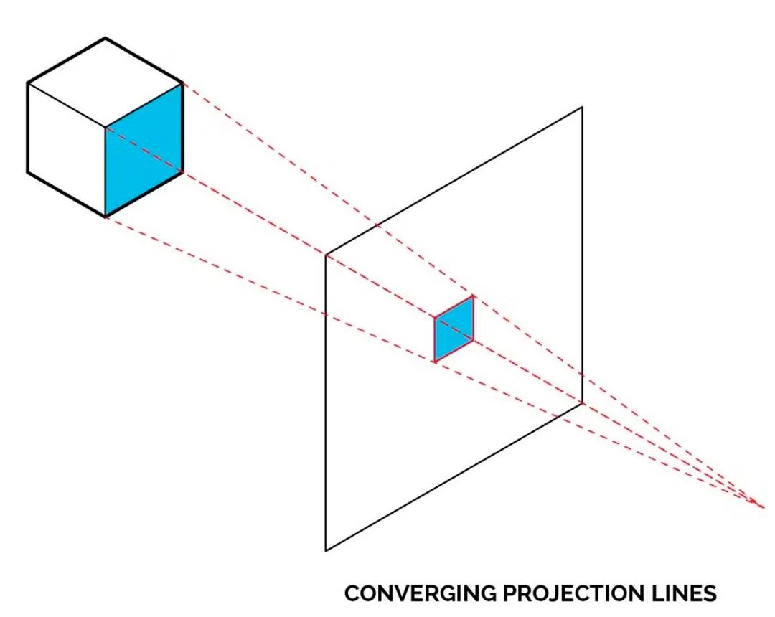
5
Unlike parallel projection, the projection lines generally converge.
This produces the visual effect that objects farther away appear smaller.
Perspective projection is fundamental to:
- Computer graphics.
- Photography.
- Architecture.
- 3D visualization.
- Video games.

Projection vs. Transformation
# Source: AI Source: Provided by: [Data Path: Persons Table -> ID Column: 1, Name_En Column: Motasem Essam] -> From: [ChatGPT] on [7/25/2026]
Projection can be considered a type of geometric mapping/transformation, but it is different from the classical transformations commonly studied in elementary geometry.
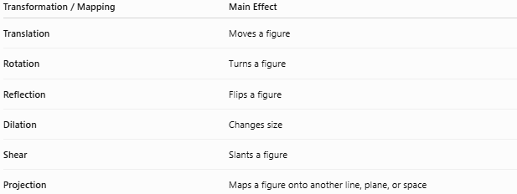
Transformation / Mapping | Main Effect
Translation | Moves a figure
Rotation | Turns a figure
Reflection | Flips a figure
Dilation | Changes size
Shear | Slants a figure
Projection | Maps a figure onto another line, plane, or space
The important distinction is that the classical transformations such as translation, rotation, reflection, and dilation generally map a figure to another figure of the same dimension, while projection can reduce dimension.
For example:
$$\text{3D object}→\text{2D plane}$$
or:
$$\text{2D figure}→\text{1D line}$$

Important Properties
1. Orthogonal projection creates a perpendicular
$$\boxed{PP^{'}⟂l}$$
2. Projection gives the shortest point-to-line distance
For a point $P$:
$$\boxed{d(P,l)=PP^{'}}$$
3. Projection can reduce dimension
For example:
$$\text{plane}→\text{line}$$
or:
$$\text{space}→\text{plane}$$
4. Projection does not generally preserve lengths
For a segment:
$$A^{'}B^{'}≤AB$$
for orthogonal projection.
Equality occurs when the segment is parallel to the projection line.
5. Projection does not generally preserve angles
Unlike rigid transformations, projection can change the angles between lines.

Projection and Triangle Altitude
# Source: AI Source: Provided by: [Data Path: Persons Table -> ID Column: 1, Name_En Column: Motasem Essam] -> From: [ChatGPT] on [7/25/2026]
This relationship is particularly important in plane geometry.
If $D$ is the projection of $A$ onto $BC$:
$$\boxed{AD⟂BC}$$
then $AD$ is also the altitude from $A$.
Therefore:
$$\boxed{\text{Orthogonal projection of a vertex onto the opposite side}=\text{foot of the altitude}}$$
This connects the concepts of:
Projection → Perpendicularity → Altitude → Triangle Area

Projection and Triangle Area
# Source: AI Source: Provided by: [Data Path: Persons Table -> ID Column: 1, Name_En Column: Motasem Essam] -> From: [ChatGPT] on [7/25/2026]
Suppose $AB$ is the base of a triangle and the altitude from $C$ has length $h$.
The altitude is the perpendicular projection distance from $C$ to the line $AB$.
Therefore:
$$\boxed{A=\frac{1}{2}bh}$$
Projection therefore provides the height needed for calculating the triangle's area.

Real-World Applications
# Source: AI Source: Provided by: [Data Path: Persons Table -> ID Column: 1, Name_En Column: Motasem Essam] -> From: [ChatGPT] on [7/25/2026]
Projection is used in:
- Engineering drawings — representing 3D objects on 2D paper.
- Architecture — creating floor plans and elevations.
- Computer graphics — converting 3D scenes to 2D screens.
- Photography — modeling perspective.
- Cartography — projecting Earth's surface onto maps.
- Physics — resolving vectors into components.
- Robotics — calculating positions and directions.
- Surveying — determining horizontal and vertical distances.

Applications
# Source: AI Source: Provided by: [Data Path: Persons Table -> ID Column: 1, Name_En Column: Motasem Essam] -> From: [ChatGPT] on [7/25/2026]
Geometric projection is commonly used for:
- Finding perpendicular distances.
- Calculating triangle heights.
- Calculating projected lengths.
- Resolving vectors.
- Creating technical drawings.
- Creating 2D representations of 3D objects.
- Mapping curved surfaces onto planes.
- Computer vision and 3D graphics.

Advantages
# Source: AI Source: Provided by: [Data Path: Persons Table -> ID Column: 1, Name_En Column: Motasem Essam] -> From: [ChatGPT] on [7/25/2026]
- Simplifies complex geometric objects.
- Converts higher-dimensional representations into lower-dimensional ones.
- Makes perpendicular distances easy to determine.
- Provides a direct connection to trigonometry.
- Is useful for vector calculations.
- Is fundamental to technical drawing and computer graphics.

Limitations
# Source: AI Source: Provided by: [Data Path: Persons Table -> ID Column: 1, Name_En Column: Motasem Essam] -> From: [ChatGPT] on [7/25/2026]
- Projection can change lengths.
- Projection can change angles.
- Some information can be lost when reducing dimensions.
- Different projection methods produce different representations.
- Perspective projection can introduce distortion.
- A projected figure may not preserve the original shape exactly.

Comparison with Related Concepts
# Source: AI Source: Provided by: [Data Path: Persons Table -> ID Column: 1, Name_En Column: Motasem Essam] -> From: [ChatGPT] on [7/25/2026]
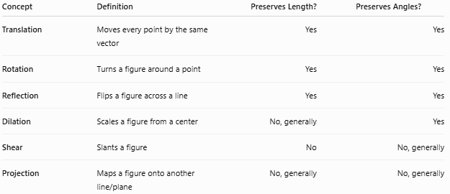
Concept | Definition | Preserves Length? | Preserves Angles?
Translation | Moves every point by the same vector | Yes | Yes
Rotation | Turns a figure around a point | Yes | Yes
Reflection | Flips a figure across a line | Yes | Yes
Dilation | Scales a figure from a center | No, generally | Yes
Shear | Slants a figure | No | No, generally
Projection | Maps a figure onto another line/plane | No, generally | No, generally

Key Points
# Source: AI Source: Provided by: [Data Path: Persons Table -> ID Column: 1, Name_En Column: Motasem Essam] -> From: [ChatGPT] on [7/25/2026]
- Projection is a geometric mapping from one object or space to another.
- Orthogonal projection uses perpendicular projection lines.
- For point $P$ projected onto line $l$:
$$\boxed{PP^{'}⟂l}$$
- The projection point $P^{'}$ is the closest point on the line to $P$.
- A triangle's altitude can be viewed as the orthogonal projection of a vertex onto the opposite side.
- Segment projection is related to cosine:
$$\boxed{L_{\text{projection}}=L|cosθ|}$$
- Vector projection uses the dot product.
- Oblique projection is not necessarily perpendicular.
- Parallel projection uses parallel projection lines.
- Perspective projection uses converging projection lines.
- Projection is a type of geometric mapping, but it is not one of the classical rigid transformations such as translation, rotation, or reflection.

Conclusion
# Source: AI Source: Provided by: [Data Path: Persons Table -> ID Column: 1, Name_En Column: Motasem Essam] -> From: [ChatGPT] on [7/25/2026]
Geometry projection is the process of mapping a geometric object onto another line, plane, or space according to a specified projection direction. The most fundamental form in plane geometry is orthogonal projection, where the projection is perpendicular to the target line. Projection is closely connected to altitudes, perpendicular distances, trigonometry, vectors, and area calculations, and it becomes especially important in engineering, architecture, cartography, computer graphics, and 3D geometry.

